**Lightinthebox Poland Warehouse Return Form**

--------------------------------------------------------------------------------------------------------------------

**Order Number** and **RMA code(s)** are **required**:

|  |  |  |  |  |  |
| --- | --- | --- | --- | --- | --- |
| **Order Number :** | | | | | |
| **Item** | **RMA code** | **Qty** | **Item** | **RMA code** | **Qty** |
| **1** |  |  | **5** |  |  |
| **2** |  |  | **6** |  |  |
| **3** |  |  | **7** |  |  |
| 2**4** |  |  | **8** |  | 2 |

--------------------------------------------------------------------------------------------------------------------

**RETURN INSTRUCTIONS**

1. Please pack items carefully to make sure no damage will cause in shipment especially items with screen. (For electronics products, please remove all password or personal information, and put all original accessories in package)
2. Print **TWO copies** of this Return Form, and **STICK** **one copy OUTSIDE** the package and **put the other one IN the package**. Because these two papers are the **ESSENTIAL part to IDENTIFY your package**.
3. Please ship the package out within 5 days and keep the receipt as the proof of return, please use the **Cheapest Shipping Method to return**, usually we will receive it within **7-14 days**.
4. The wareuse is a Third PARTY SHIPPING WAREHOUSE who ONLY accepts return and transfer shipping packages on LightInTheBox behalf. EUROPLIS DOES NOT handle any other issues such like our after-sales service. Please contact Lightinthebox Customer Service if you have further problem.
5. Once it is delivered, we’ll arrange the refund or replacement based on the agreement in **5 Business Days** and we’ll create a new Ticket to inform you about that.

--------------------------------------------------------------------------------------------------------------------

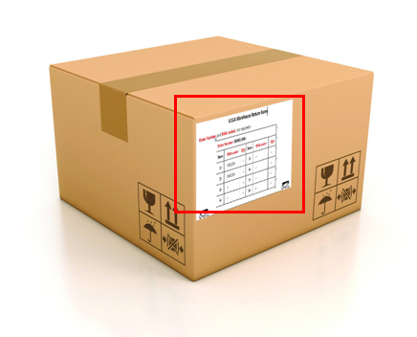**RETURN ADDRESS**

Name: LITB

Address: Wola Bykowska 31

City: Grabica

Country: **POLAND**

Postal Code: 97-306

------------------------------------------------------------

STICK ONE RETURN FORM ON THE PACKAGE